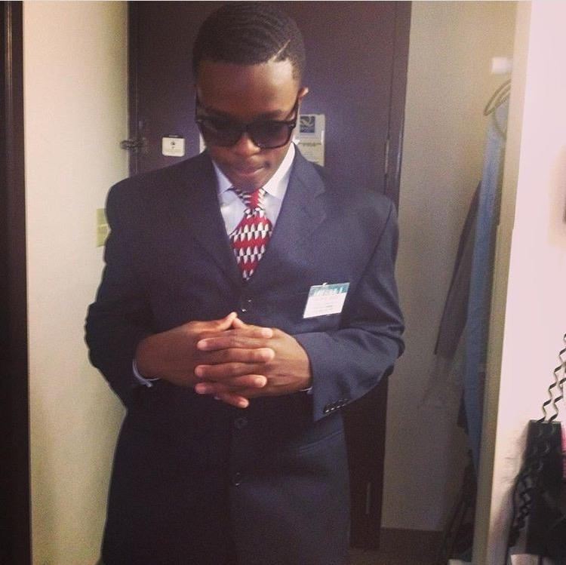
Jehofasolape Olaniyan
5006 70th ave (202) 394-5968
Hyattsville, MD 20784 solapeolaniyan5006@gmail.com

Objective Be able to engage in Cyber Security and Major in Computer Science. My main goal in life is to be able to help people with computer problems and be able to render my assistance to them.

Education Laurel High School (2015-Present) Laurel, MD
CCENT Certified (2016)

Honors/Awards High School Honor Roll (2013-2016)
Futurist Scholarship ($32,000) (2016)
Accepted in Cisco Academy (2016)
CPR Certified (2015)

Clubs IT Club (2015-2016)
Brothers Basketball League (2014-Present)

Personal Skills • Effective time management
• Ability to be organized and to meet deadlines
• Very courteous and polite with customers
• Excellent verbal and communication skills
• Proficient on working with LANS, VLANS, SWITCHES, and ROUTERS
• Advanced in Microsoft Word, Excel, and PowerPoint
Volunteer Experience
PG Student-Built House Project (2016-2017)
- Installed Ethernet Cabling at a home
- “Keypad and Motion Detectors”
Work Experience
Intern at Aurotech Corp (August 2016-present)
Interests
      - Helping People
      - Traveling
      - Playing Sports
      - Working on Computers
      - Making New Friends

References Available upon request

